Contents

1. Mysql INSTALLATION STEPS 2

1. Download link 2

2. Selecting installer for Windows x64 2

3. Proceeding with download 3

4. Beginning installation 3

5. Define MySQL server data location 4

6. Skip installation for two products 4

7. Dependencies installation 5

8. Proceed with product configuration 5

9. Type and networking 6

10. Authentication method 6

11. Windows service 7

12. Apply configuration 7

13. Finish product configuration 8

# Mysql INSTALLATION STEPS

## Download link

<https://dev.mysql.com/downloads/windows/installer/8.0.html>

## Selecting installer for Windows x64

Choose installer type, the second one (mysql-installer-community-8.0.23.0.msi).

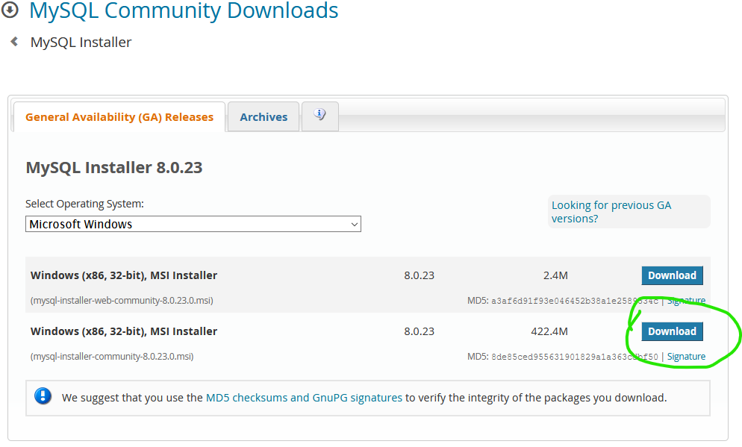

Figure 1 - Choosing MySQL server installer

## Proceeding with download

Click on the “No thanks, just start my download”.

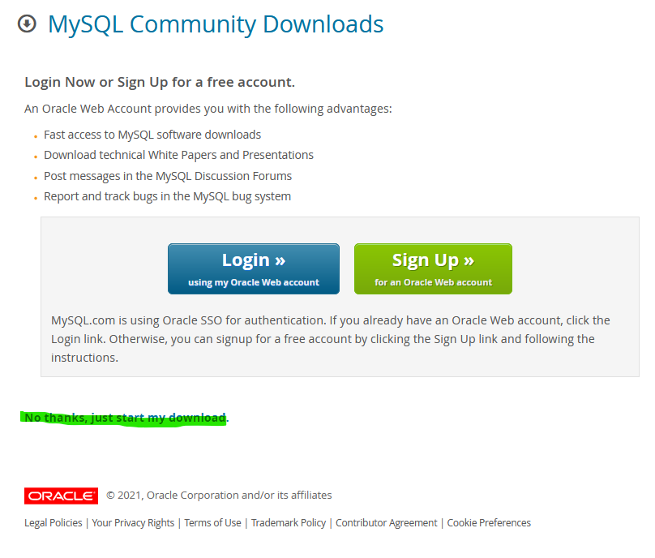

Figure 2 - Proceeding with download

## Beginning installation

Select default option => “Developer Default”.

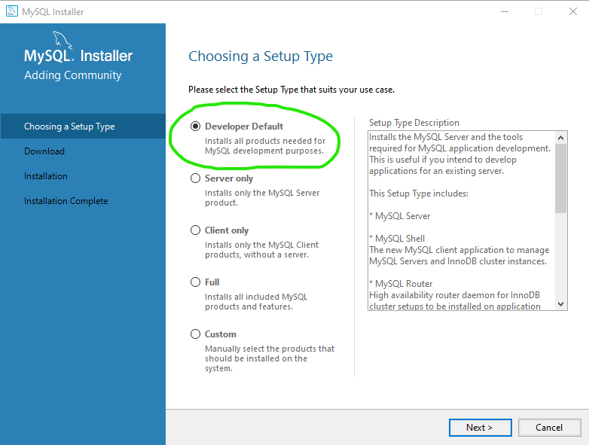

Figure 3 - Beginning installation

## Define MySQL server data location

If you receive warning that install directory and data directory are the same, you can define new location for data. For example, “C:\MySQL Server 8.0\data”.

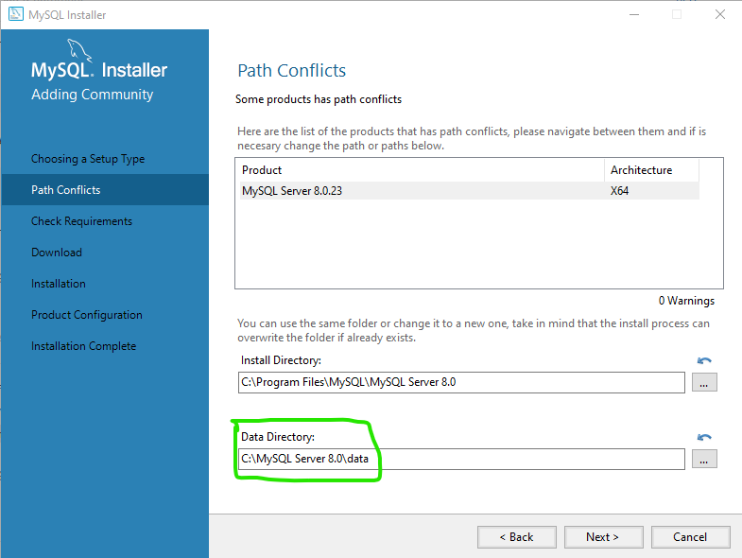

Figure 4 - Define data folder

## Skip installation for two products

Since these two products are not needed for our development process, skip their installation.

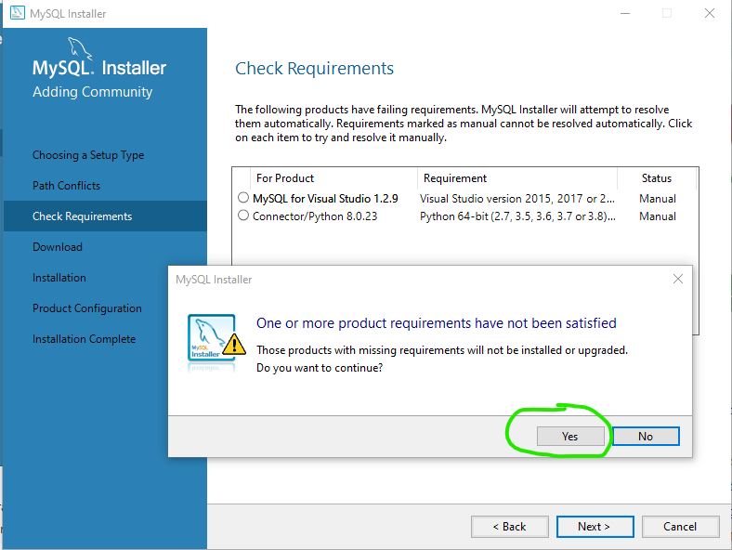

Figure 5 - Skipping installation for two products

## Dependencies installation

Proceed with dependencies installation. Click on “Execute” button.

When finished, click on “Next” button.

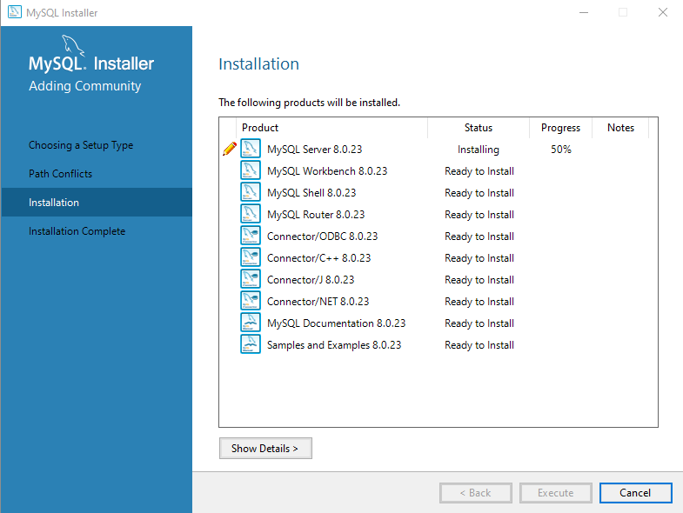

Figure 6 - Dependencies installation

## Proceed with product configuration

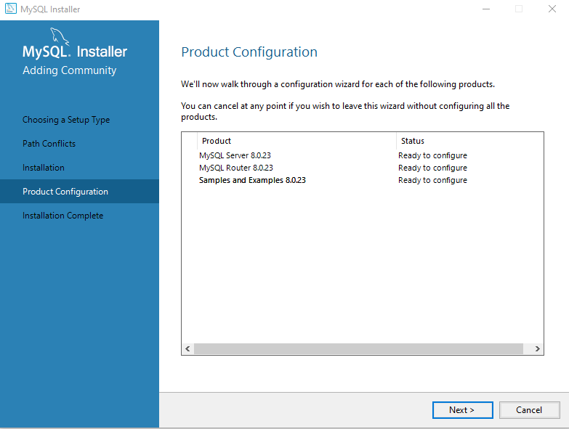

Figure 7 - Proceed with configuration

## Type and networking

Proceed with default selection (“Development computer”).

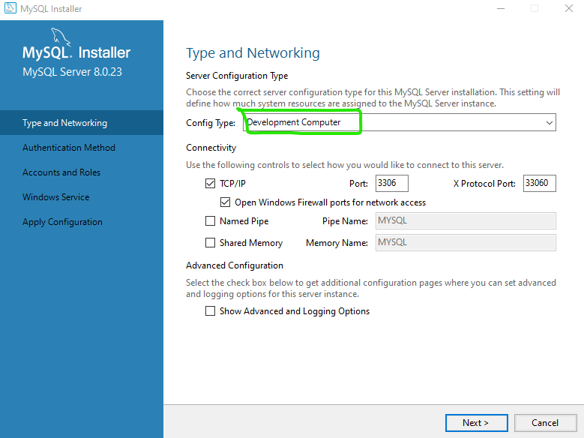

Figure 8 - Type and networking

## Authentication method

Select “Use Legacy Authentication Method”.

Enter root user password on the next screen.

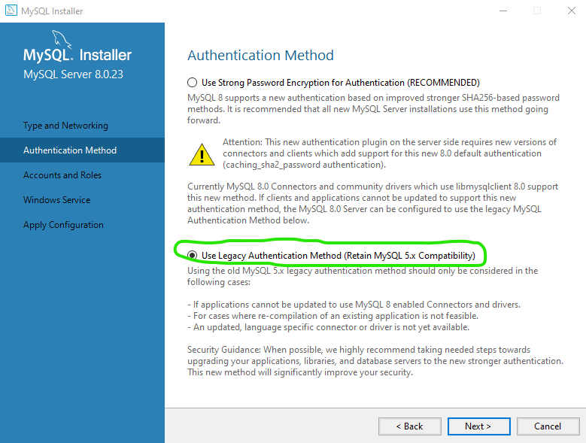

Figure 9 - Authentication method

## Windows service

Use default settings, selected options are shown on the next picture.

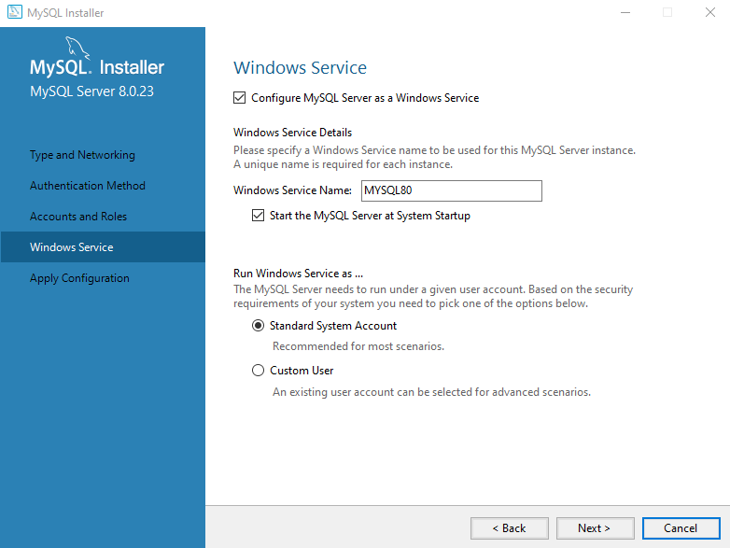

Figure 10 - Windows service

## Apply configuration

Just click on the “Execute” button.

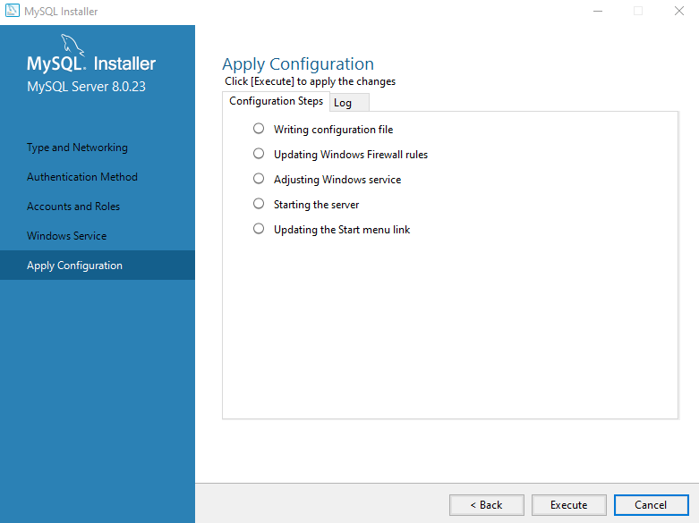

Figure 11 - Apply configuration

## Finish product configuration

Continue to select default settings until installation is finished.

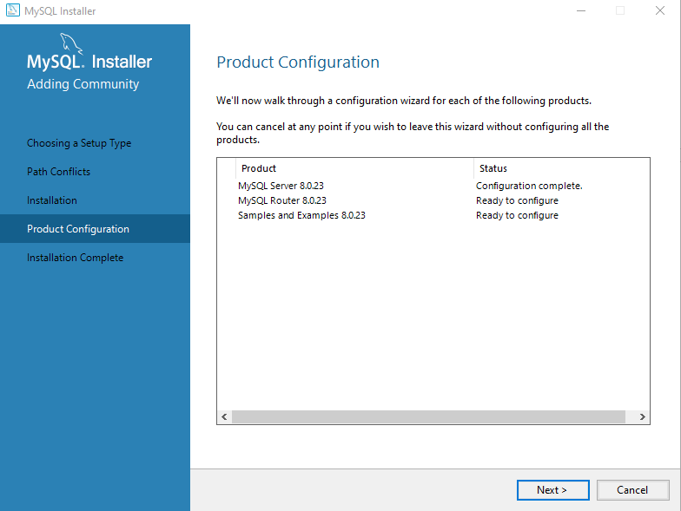

Figure 12 - Finish installation